PERSONAL PROPERTY AUCTION
SATURDAY, APRIL 27, 2024, 10:00 A.M.
SALE LOCATION: 56 38th AVENUE, TRENTON, MO 64683
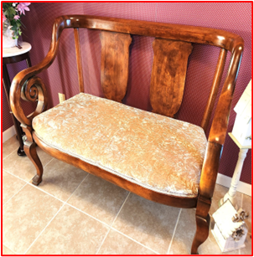
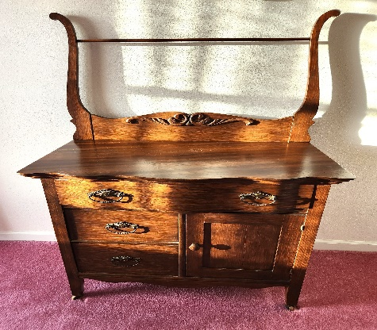
DIRECTIONS: Travel west of Trenton on Hwy 6 two miles to Hwy 146. Go north one mile to 38th Street then one-tenth of a mile to sale site. Watch for Auction Signs.
AUCTIONEER’S NOTE: Glendola is downsizing and will be offering a nice assortment of antiques, collectibles, furniture, and tools from a clean, non-smoking home.

Furniture-Household-Antiques-Collectibles: Centurion 10 Gun Safe; Haier 9.8 Cu Ft Refrigerator/Freezer (like new); Kenmore Dorm Refrigerator; 4 pc Cherry Set-Sofa table, Coffee Table, 2-End Tables; Walnut Library Table; Children’s Toy Box Bench; 2-Mauve Wing Back Chairs; Small White Spindle Leg Table; Assorted Book Shelves; Wine rack; Crystal base lamp; Wood Office Desk w/ Chair; Hall Tree; 2-Bent Back Wooden Chairs; 55” White Dresser; Wrought Iron bed frame; Rocking chair; Art cart; Twin Bed frame;
3 - white/gray bar stools; Chest of Drawers; Entertainment Center; Burgundy Leaf Pattern Love Seat; Accent Swivel Rocker; 3 Pc White Wicker Set- Chair, Stool, Shelf; Cadence XT Electric Treadmill; Ornate Tiger Oak Hall Tree Bench (super nice!); Victorian Entry Bench; Victorian settee, rolled arm; Victorian Style Table Lamp; Antique sewing machine; Antique dresser; Victorian 4 pc furniture set to include straight back arm chair, settee, foot stool, and rocker – oak w/neutral print fabric, Oak School Desk; Antique Inlaid Secretary; Walnut Antique Spindle Leg Lamp Table; White Antique Wrought Iron Full Size Bed; Antique Wrought Iron Painted Bird Cage; Oak Wash Stand; Oak Sewing Rocker; Oil Lamps; Cast Iron Broiler & 2 Kettles; Beer Stein Collection; Super Nintendo; Miida 8-Track Stereo Receiver; Refrigerator Dishes; Glass Insulator; Mansfield Slide Projector; 2 Kodak Slide Carousels; Projector Screen; Several Slide Trays; Misc. Cameras; 2-31 Day Kitchen Clocks; 2-4 Drawer File Cabinet; Assorted Books; Small Kitchen Appliances; Misc. Pots, Pans, Cookware, Dishes; Misc. Glassware; Assorted Pictures & Prints; Assorted Decorative Bird Houses; Area Rugs; Suit Cases; Misc. Household Décor, 2 – window AC units Wii game (bowling and rifle)

Lawn & Garden-Tools: Greenworks 17” Electric Push Mower w/Bagger, 40V Lithium Battery; Craftsman 24” elec. start snow blower (works great); 2 bicycles; Rigid Shop Vac; 2- Master Mechanic 10” Table Saws; Craftsman Router & Hirsch Router Table; 2- 6” Bench Grinders; Echo Chainsaw; Poulan Electric Chainsaw; Corded Power Tools; 2 Battery Chargers; Sod Master Sod Cutter, Minneapolis, MN 1960’s; Craftsman Tool Box; Small Rolling Tool Box; Assorted Hand Tools; Assorted Wrenches, Sockets; Misc. Organizers; Misc. Step Ladders; Misc. Extension Cords; Hand Truck; Appliance Dolly; 2 Hose Caddies; Assorted Hand, Lawn & Garden Tools; Galvanized Wash Stand, Single Tub; Plastic Lighted Choir Children; Small Patio Set, Table, Umbrella, 4 Chairs; Small Iron Patio Bench; 12 ft stick of 6” SDR35 sewer pipe & More

See Pics & Complete Sale Bill @ www.shomemoreauctions.com or Jumps and Roy Auction Facebook

Glendola & late Raymond Klinginsmith Auction

SALE CONDUCTED BY: Jumps & Roy Auction, LLC
Rustin Jumps & Scott Roy
Gallatin & Trenton, MO
660-605-0860 or 660-359-1455
www.jumpsandroyauction.com

TERMS: Cash or check w/ proper I.D. Not responsible for accidents, thefts, or errors in advertising. Announcements made day of auction take precedence over all advertisements.

